REACT ASSIGNMENTS
Assignment 3:
1.Create a new React application named ScoreCalculatorApp by executing the following command:
npx create-react-app scorecalculatorapp

2. Navigate to the project directory using:
cd scorecalculatorapp
3. Start the React development server by executing the following command:
npm start

4. App.js
import './App.css';
import CalculateScore from './Components/CalculateScore';

function App() {
return (
<div className="App">
<CalculateScore
Name="John"
School="ABC School"
Total={450}
goal={5}
/>
</div>
);
}

export default App;
5. Components/CalculateScore.js
import React from "react";
import "../Stylesheets/mystyle.css";

function CalculateScore(props) {

const average = props.Total / props.goal;

return (
<div className="box">
<h1>Student Details</h1>

<h3>Name : {props.Name}</h3>

<h3>School : {props.School}</h3>

<h3>Total Score : {props.Total}</h3>

<h3>Number of Subjects : {props.goal}</h3>

<h2>Average Score : {average}</h2>
</div>
);
}

export default CalculateScore;
6. Stylesheets/mystyle.css
body {
background-color: #f2f2f2;
font-family: Arial, Helvetica, sans-serif;
}

.box {
width: 500px;
margin: 50px auto;
padding: 20px;
border: 2px solid #333;
border-radius: 10px;
background-color: white;
text-align: center;
}

h1 {
color: blue;
}

h2 {
color: green;
}

h3 {
color: #333;
} 7. Result
The React application was developed successfully. The student details, including the student's name, school, total score, number of subjects, and calculated average score, were displayed correctly using React functional components, props, and CSS styling.
8. Output
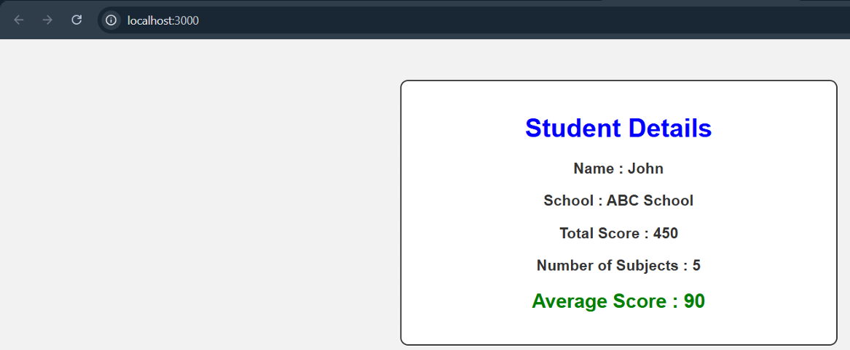

9. Conclusion
The experiment was completed successfully. A React application named scorecalculatorapp was created using multiple reusable functional components. The components were imported and rendered through the main App component, demonstrating the basic concept of component creation and rendering in React.

